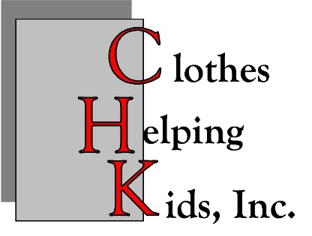
2026
Clothes Helping Kids, Inc.
Grant Application for Central and Northern New Mexico Programs.

Name of Organization:
Name of Program (if different):
Employer Identification Number (EIN#):
Mailing address (include city, state, and zip):

Physical address (if different from mailing address, include city, state and zip):

Contact Person:
Title:
Telephone (include area code):
Fax (include area code):
E-mail:

Total Amount Requested: $
County or Counties in NM:
Program Type (e.g. educational, health, etc.):

- Short summary (no more than 500 words). Explain the history and purpose of the organization, length of time in existence, organizational status [e.g. 501-(c)-3 nonprofit, school, tribe] and what the focus on children and youth is.

- Short summary (no more than 500 words). What will CHK Grant funds support and how will the funds address CHK’s priorities? Include (1) What is expected to be achieved; (2) The number of children and/or youth expected to be involved; (3) What the program goals are. Also note how you will evaluate the use of CHK funds.

- Short summary (no more than 500 words). Explain how a CHK Grant received will make a difference in the program goals. Will your organization/the program leverage other funds if you receive this grant? If so, from whom will you apply/receive additional funds?

- Complete this application with a budget for the amount requested and the program costs.
An IRS letter of determination must be included even if you have previously provided one to CHK.
Expense Item Amount Requested Other Funding Total

1._______________ ________________ ________________ $______________

2._______________ ________________ ________________ $______________

3. _______________ ________________ ________________ $______________

4. _______________ ________________ ________________ $______________

5. _______________ ________________ _________________ $______________

6. _______________ ________________ _________________ $______________

Total Amount Requested: $ ___________________.

