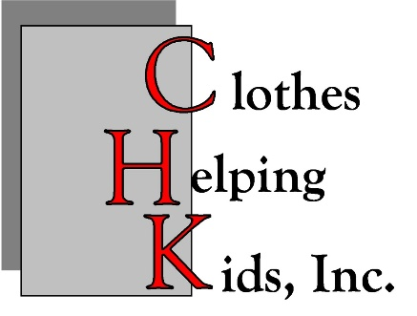

**2025**

**Clothes Helping Kids, Inc.**

**Grant Application for Central and Northern New Mexico Programs.**

**Information and Requirements**

Clothes Helping Kids, Inc. (CHK), a nonprofit organization established in 1999, collects used clothing and household goods for resale. Net income generated from these donations is awarded in grants to community-based organizations (not individuals) supporting children and youth in Central and Northern New Mexico, within the following counties: **Bernalillo, Colfax, Guadalupe, Los Alamos, Mora, Rio Arriba, San Miguel, Sandoval, Santa Fe, Taos, Torrance, and Valencia.**

The Board of Directors of CHK reviews all applications and selects grantees on a competitive basis. Applications must be for programs that work directly with children and/or youth, and address educational needs, health issues, human services, environmental concerns or traditional arts and culture. The Board has set these priorities, singly or in combination, as they believe these address significant developmental needs of children and youth.

Clothes Helping Kids welcomes applications from established not-for-profit organizations seeking up to **$6,000** to support ongoing or new initiatives. In 2025, the Board of Directors will select grantees that best address CHK’s priorities. Notifications will be sent by USPS to all applicants by **late-April 2025,** regarding the status of your application.

Applications will be evaluated on:

* Quality of focus on children and youth and the number of children/youth engaged;
* Proposed impact and effectiveness of the proposed program;
* Demonstrated need for this funding to accomplish the goals of the program;
* Geographic location of activities;
* Capacity to implement and administer the program;
* Commitment to evaluate program outcomes and report in a timely manner to CHK.

The Board of Directors has sole authority on all grant decisions.

**Each grant recipient is required to report on the expenditure of funds and submit an evaluation and summary of the program the funds supported by Friday, January 16, 2026; a template will be provided. FAILURE TO SUBMIT A TIMELY REPORT WILL DISQUALIFY THE ORGANIZATION FROM FUTURE APPLICATION.**

**ALL FUNDS MUST BE SPENT BY WEDNESDAY, DECEMBER 31, 2025. Any unused funds must be returned to CHK, unless written authorization is granted at least thirty (30) days prior to WEDNESDAY, DECEMBER 31, 2025.**

**PLEASE NOTE:**

Applications will not be reviewed if they request funds:

* For political or religious purposes;
* To retire indebtedness;
* For payment of interest or taxes or emergency needs;
* For annual campaigns or endowments;
* To influence legislation or elections;
* For private foundations;
* For organizations that discriminate based on race, color, sex, age, religion, national origin, gender, familial status, marital status, disability, or genetic information.

Grant applications shall be a **maximum** of five (5) pages and include a copy of the organization’s IRS letter of determination and budget (form provided below). **An IRS letter of determination must be included even if you have previously provided one to CHK.** Please **do not** submit additional literature or include photographs as they will not be included in the review process. (The IRS letter of determination is not part of the maximum five (5) pages allowed.) Please do not include application instructions when submitting your application.

Applications should be scanned and e-mailed to nm@clotheshelpingkids.org. **All applications MUST be received by THURSDAY FEBRUARY 27, 2025.** Any application received after the deadline, or that does not provide all information requested or exceeds the 500-word limit, will **not** be considered for review.

**Upon receipt of your completed application, an e-mail confirmation will be sent within two (2) business days. If you do not receive a confirmation notice in two (2) business days, please call the office at (505)-266-2002. Applications are processed and submitted to the Board shortly after the deadline, so it is of utmost importance that any inquiries regarding the receipt of an application are made in a timely manner for your application to be considered.**

**Due Diligence Compliance: Grant applicants are reminded that U.S. Executive orders, and U.S. law prohibit transactions with and the provision of resources and support to individuals and organizations associated with terrorism. It is the legal responsibility of the grant applicant to ensure compliance with these Executive orders and laws.**